2022

Lovelyn Nnasor

[SHEFFIELD](https://www.shu.ac.uk/) HALLAM UNIVERSITY



FytSmart design and development report

**INTRODUCTION**

T his report has been produced by Lovelyn Nnasor. In this report, the decision for creating the FytSmart application is justified by the design, market and implementation research before its creation. The market need for this fitness application and different weaknesses in the current prevailing environment relevant to such applications is identified and tried to express those needs in FytSmart.

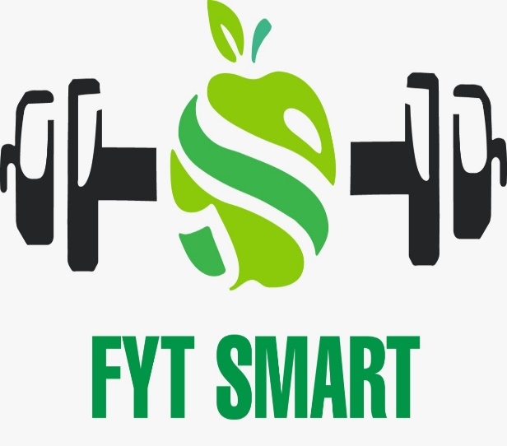

FytSmart is a fitness and diet application designed to boost healthy living through its unique encompassing features that incorporates home fitness activities, diet stations that provides users with local stores near them to shop healthy foods and fitness wears around them.

This application would help increase the number of genuinely happier, confident people with a will to live in their desired body shapes in Sheffield.

**DECISION MAKING**

The user interface was created by hand. I came up with two of concepts for the application following discussing a few sessions to deliberate on the problem definition. It was either intended to become a beginner's workout application or a good meal application. However, upon exploring the field and discussing with the lecturers, I chose to construct an all-in-one application that enables users to choose from a number of home-based exercise options as well as locate a healthy meal location near them.

Here are some reasons for choosing to make all-in one applications are as:

Uniqueness of application from other applications already existed

Avoid users from complications by indulging them in a complex structure

A lot of features to design will make it stupendous

**MARKET GAP**

In my experience, I saw a market gap for those who desired to:

* Avoid hustle of going to gym (house wives/woman)
* Choose an all-in one application for both exercises as well as healthy meal
* Choose an application with simple, easy-to-follow and less complex processes and functionalities.

As a result, the application FytSmart was designed with the broader age category in consideration, and the functionalities were included to meet the unmet needs of the intended audience.

**DESIGN APPROACH**

Prior objective — To give nutritious and sustained health goals in users' lives and to improve living standard by creating a healthier living a norm through functionality such as surveillance, posting results, evaluating outcomes, and locating healthy food centers.

Targeted audience — Workout lovers and health-conscious individuals, as well as newbies in fitness, in the age range of 18–45, both men and women.

Primary functionalities — To establish home-based exercise objectives as well as provide guidance to healthier food suppliers.

* Legit tracking of exercises such as whole-body workouts or workouts in portions is possible, and statistics may be examined, recorded, and contrasted.
* Evaluate accomplishments as soon as possible.

Technology variants — Web access, latest Android/IOS variant, Fitness trackers compatibility

Inter communication — Applications for Android, iOS, and the website.

Key Success Ingredients — Strategic planning and progress tracking boost app participation and enhance crucial basis for determining. Full body exercises on the platform provide users more options.

**COMPETITIVE ANALYSIS**

The number of parameters and user experience when using various health applications available on the Playstore / Apple Store were contrasted. The graph in Figure 1 was created and used the data we acquired after using the applications for a few sessions.

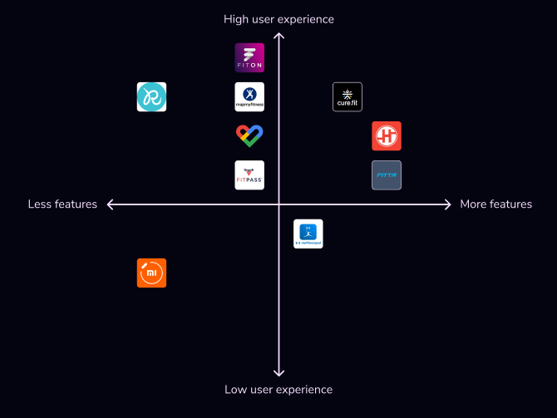

Figure 1 --- Comparative graph of fitness apps

After analysis I concluded that not much applications provide all-in services. I further found out that motivational graphics and factors were almost missing in those applications. Moreover only a few applications provide facility of recording, comparing and evaluating statistical and computational data on timely basis.

**EVOLUTION OF VISUAL DESIGN**

Figure 2, 3 and 4 shows the difference of wireframes of pen on paper version and visual version.

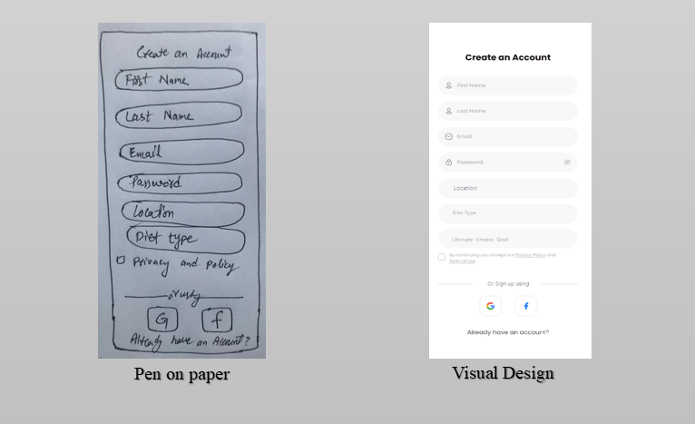

Figure 2

In this figure there were 6 sections initially. But after putting it to visual design, one more section for setting fitness goal was also required. Along with the privacy policy there was also terms and conditions in visual design.

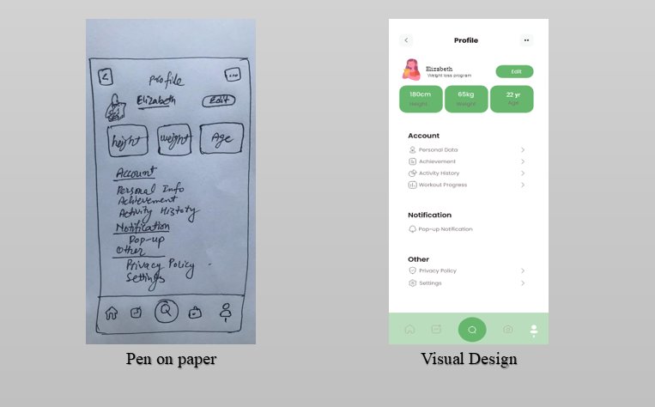

Figure 3

In this wireframe, workout progress and mentioning of weight loss program seems to be necessary while converting from pen and paper to visual design.

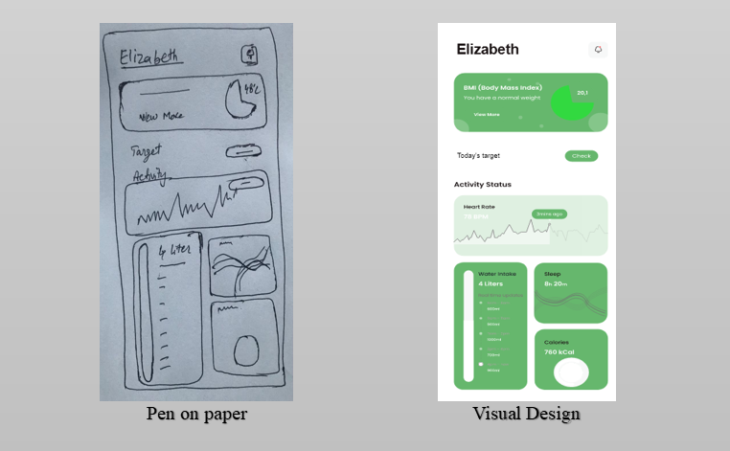

Figure 4

In this wireframe, body mass index deems to be necessary in visual design. Statistics of workout progress will also be required in visual design.

**USABILITY TESTING**

After completing the design and structure of FytSmart application, usability of FytSmart was evaluated by testing.

USERS

* The first user is a 17-year young girl who is a fitness enthusiast
* The second user is a 22-year old boy working in a tech
* The third user is a housewife

TASK ASSIGNED

* To log in or sign up and reach to the home page
* To perform any of the exercise (push-ups, lunges or chair dips) by tracking activity
* To record and compare results on timely basis
* To find a nearby healthy meal provider

OBSERVATION

* The first user had no issue with signing up by providing the relevant information and successfully reach to the home page. As the user is fitness enthusiast, she wanted to make it up without a perfect tracking. She is over concerned about comparing results excessively even from minutes to minutes. However, she had completely overlook the healthy meal section of FytSmart.
* The second user had successfully sign up and reach to the main/home page. He perform all the fitness goals on timely basis and efficiently. But he is unable to find time to upload and compare results of fitness activities. However he perfectly used the healthy meal center locator.
* The third user desires to avoid the majority of the stages, so he doesn't check the complete screen and instead accepts the very first CTA that occurs. Owing to her commitments at home, she also finds it difficult to accomplish certain activities in order to meet set performance targets. Recording, uploading, and comparing progress data is tough for the user. She also skipped over the healthy meal section of the application because she is a stay-at-home mom who prefers to eat home-cooked meals.

RECOMMENDATIONS

* The user is required to effortlessly return to the previous page.
* The user should indeed be made more aware of the tracking portion. There ought to be a clear contrast made among regular practice and when the device is monitoring stages, calories, or other metrics.
* The finder of any nearby healthy meal provider should be able be find them easily without following and complex structure and procedures to get to them.

**LEARNING OUTCOMES**

It takes a collective effort to work in a team — We were a group of four people who collaborated on the design and the majority of the application's UX. It took a bit of time for the two of them to really get to understand one another (DOYLE, June 26, 2020). A meeting could be set and then have to be rescheduled or delayed because not everyone has the very same amount of time!

**TEAMWORK**

Teachers are crucial — They can be the motivational component you should get up and really do things, from leading you through your trip to driving you forward towards a target (Sharma, JULY 27, 2018).

**TEACHERS**

Accept constructive comments with a pinch of salt — We have a reputation for taking design complaints seriously, although it is vital to remember and we're more than our creations. A criticism of our architecture does not imply a criticism of ourselves (Team, October 31, 2015). We just want somebody to remain truthful with us so that we can improve.

**CONSTRUCTIVE**

**COMMENTS**

Design is a sequential process — I don`t know how many times I had to revamp a particular component or panel.  In principle, I knew that designing entails prototyping, testing, and afterwards prototyping afresh, and etc. However it's a considerably more time-consuming procedure in practice (Eby, Jan 02, 2019). It's similar to tasting a meal while it's being prepared to refine the layout when you go. It's possible that if you will not do it, it won't turn out well.

**ITERATIVE**

**PROCES**

Become a better listener – It's crucial to pay attention to the demand of the users rather than presuming that something functions only because you made it. It examines the challenges you should pay attention to another goes around. Compassion is a key aspect in establishing a connection with the user. We are also a consumer. We ought to be capable of understanding why the next user could think the same thing regarding our application if we find it unpleasant for using (Folkman, July 14, 2016).

**GOOD**

**LISTENER**

# REFERENCES

* DOYLE, A., June 26, 2020. What Are Collaboration Skills?. *the balance careers.*
* Eby, K., Jan 02, 2019. The Power of Iterative Design and Process. *smartsheet.*
* Folkman, J. Z. a. J., July 14, 2016. What Great Listeners Actually Do. *Harward Business Review.*
* Sharma, V. K., JULY 27, 2018. Why teachers are important in our life. *Klient Solutech.*
* Team, A., October 31, 2015. Taking Other People’s Opinions With A Grain Of Salt. *Aeona.*